HOW TO CREATE BRAND PROMO VIDEO USING CANVA

**Brand Name: Get-Together**

**Category: Event Organizer**

**Target Audience: All (Men, Women and Kids)**

**Email :** [**gettogther0707@gmail.com**](mailto:gettogther0707@gmail.com)

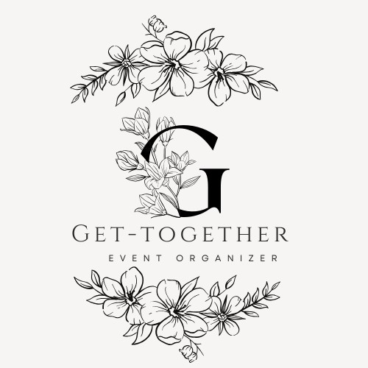

**Documentation - With Attached Screenshots for Video Creation**

**Introduction**

Welcome to the documentation for creating a brand promo video for Get-Together, your event organising brand, using Canva. In this guide, we will walk you through the steps to design an engaging and impactful promotional video. This document will include a step-by-step walkthrough, screenshots, and tips to help you get started.

**Step 1: Sign up for Canva**

* Go to the Canva website (<https://www.canva.com>).
* Sign up for a Canva account using your email address.

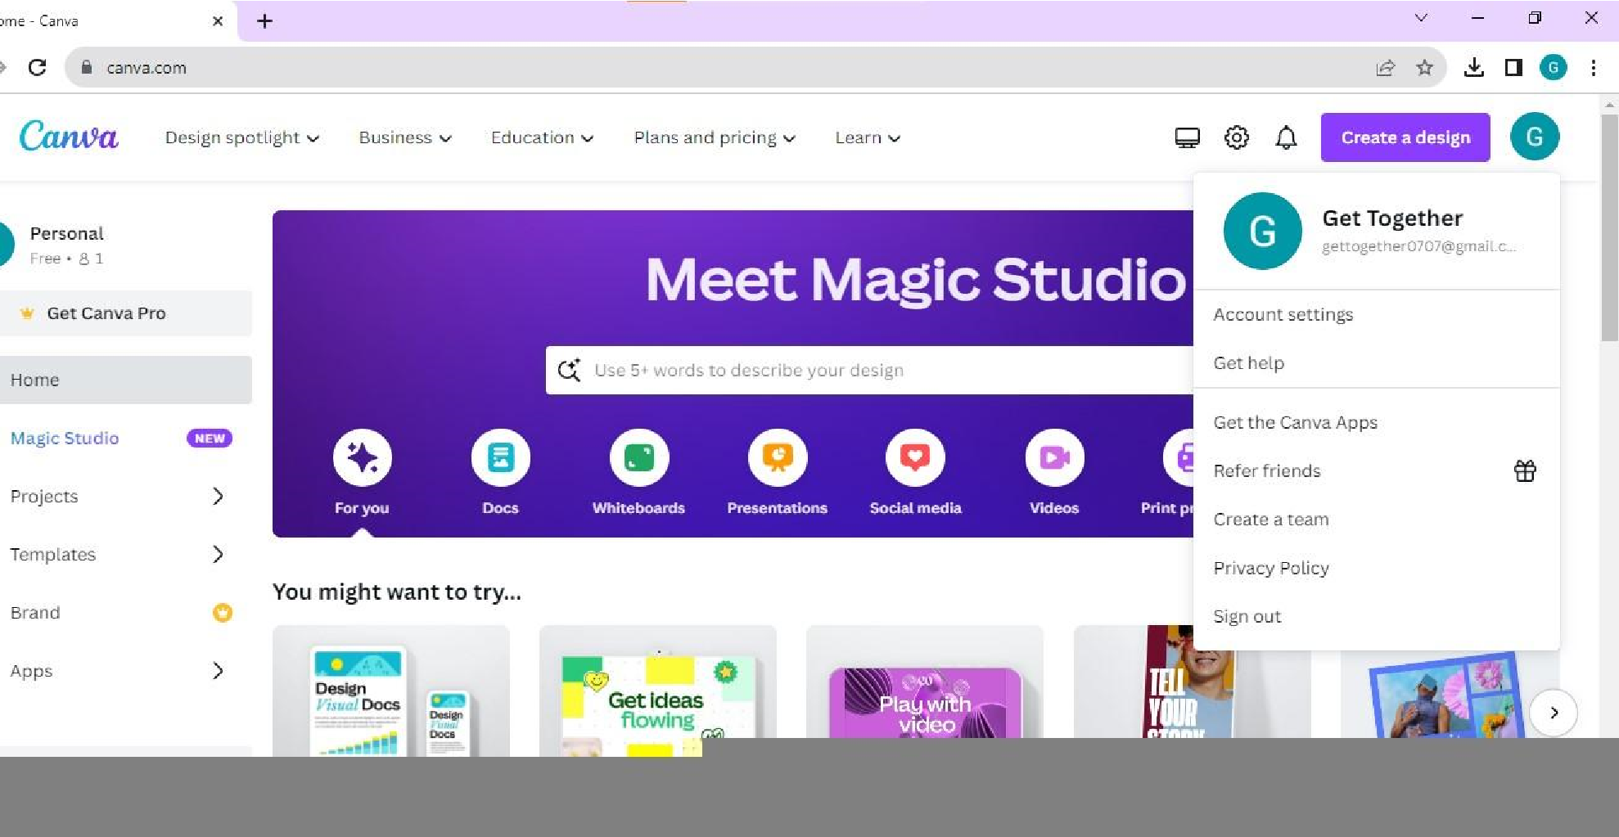

**Step 2: Access Canva’s Video Maker**

* Once you're logged in, click on "Create a design" and select "Video

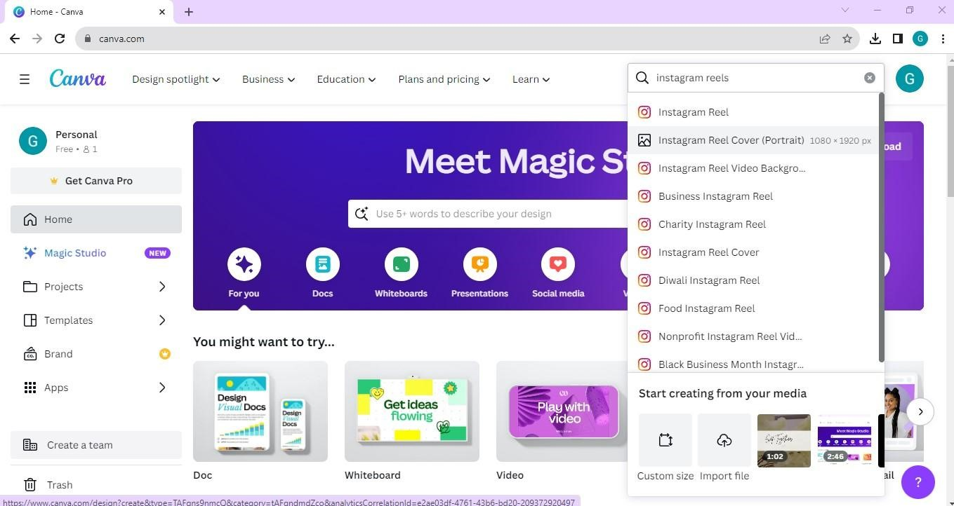

**Step 3: Choose a Video Template**

* Browse through Canva's collection of video templates. You can search for templates related to event organizing and branding.
* Select a template that suits your promotional message.

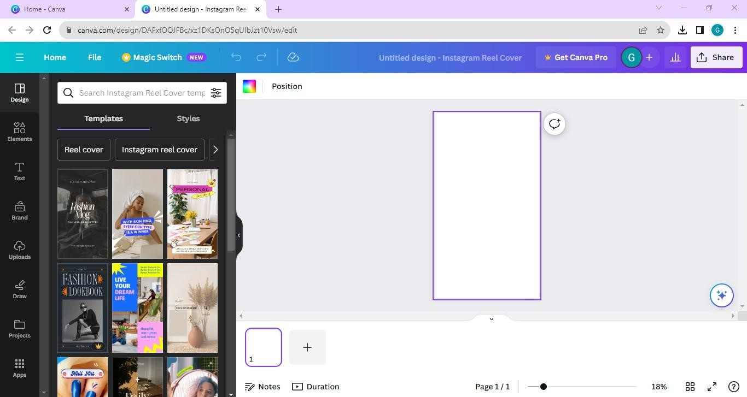

**Step 4: Customize Your Video**

* Use Canva's user-friendly video editor to personalize the template.
* Replace sample text with your brand's message and add visuals related to your event organizing services.
* Adjust fonts, colors, and transitions to match your brand's style.

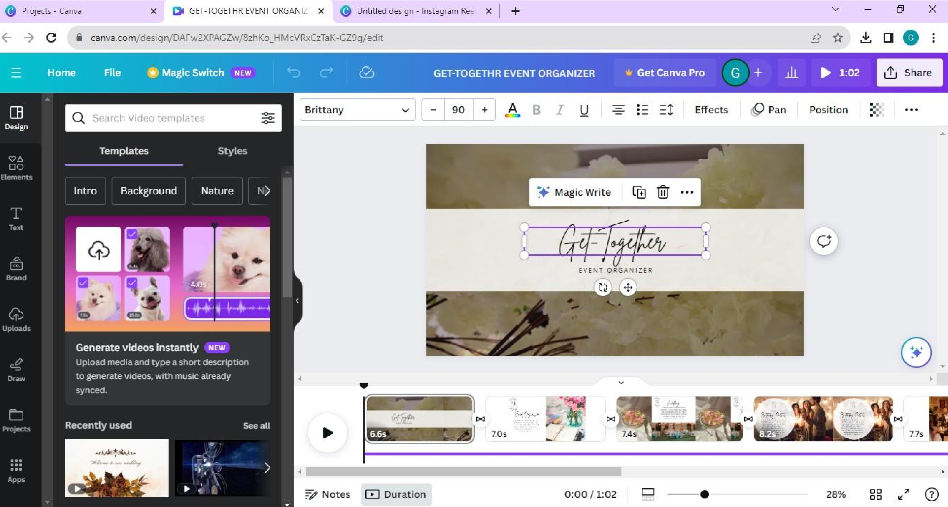

**Step 5: Add Background Music**

* Enhance the impact of your promo video by adding background music.
* Canva offers a library of music and sound effects that you can use.

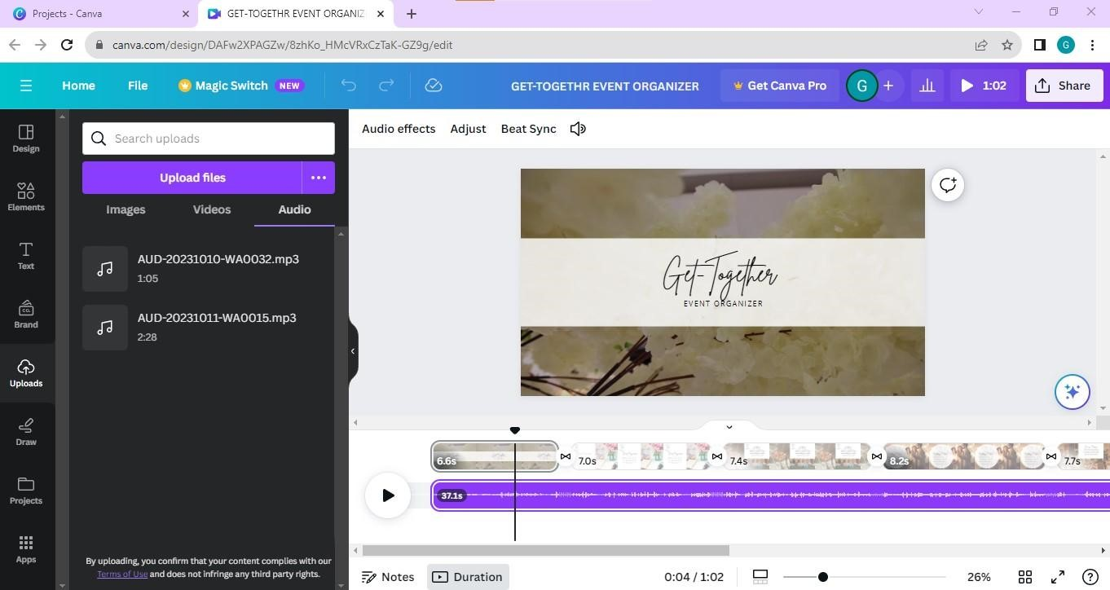

**Step 6: Add Voiceover (Optional)**

* If you want to include a voiceover, you can record and add it directly in Canva.
* Ensure the voiceover complements your brand's message.



**Step 7: Preview Your Video**

* Before finalizing, preview your video to check for any issues or inconsistencies.
* Make sure that the timing, visuals, and audio are all aligned with your brand's message.

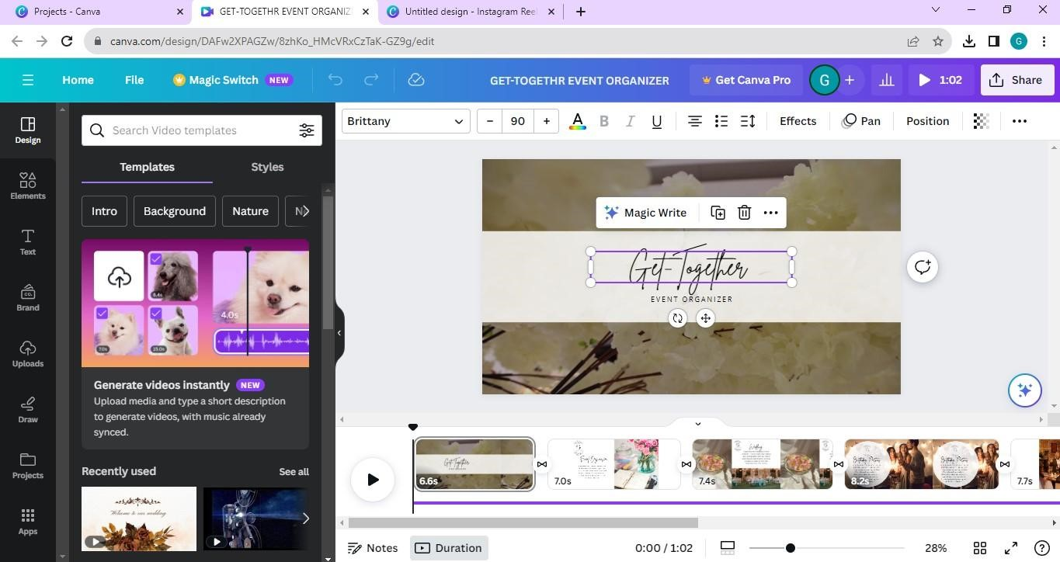

**Step 8: Export Your Video**

* Once you are satisfied with your promo video, click the "Export" button within Canva.
* Choose the appropriate video quality settings.

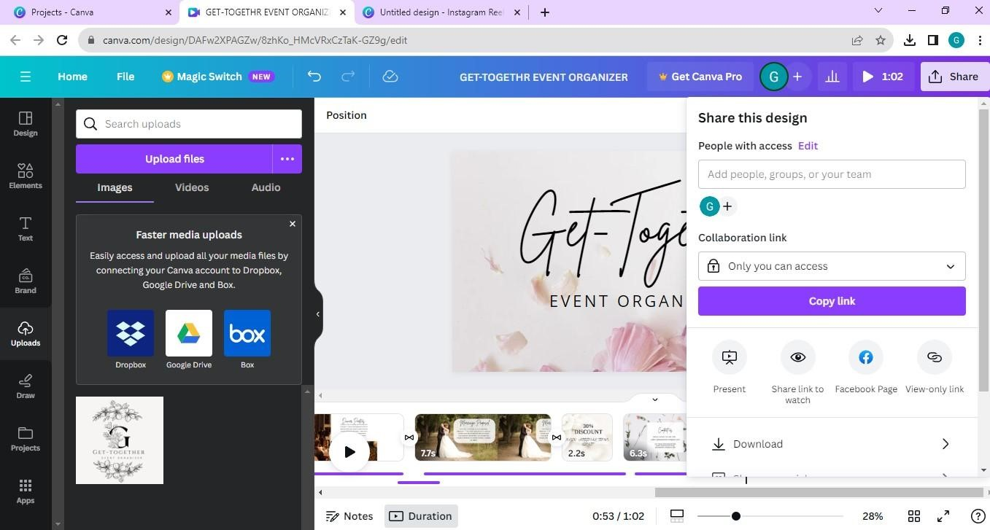

**Step 9: Share Your Video**

* You can share your video directly from Canva to social media, email, or other platforms.
* Promote your brand effectively by reaching your target audience through various channels.

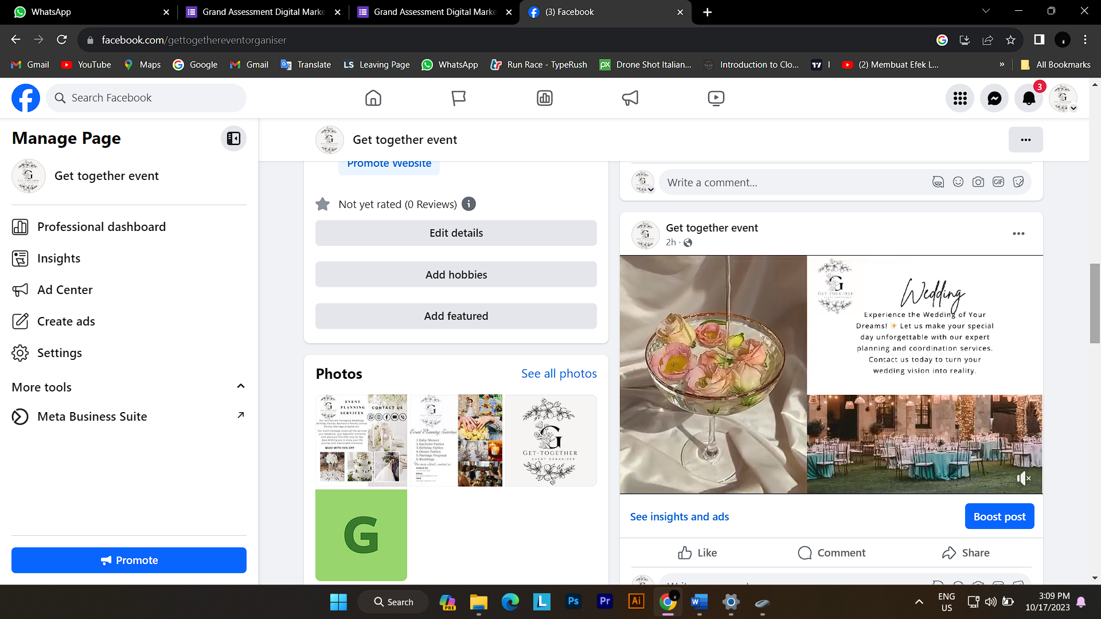

OUR PROJECT LINKS

FACEBOOK LINK: <https://www.facebook.com/gettogethereventorganiser>

BLOGGER.COM LINK: <https://eventorganising-gettogether.blogspot.com>

GITHUB LINK: <https://github.com/DRishika07/Digital-marketing>

PROMO VIDEO LINK:

<https://drive.google.com/file/d/13rLHPFd3JvLfOWhoZsK-OLPmITXy89Bh/view?usp=drive_link>

DEMO LINK:

<https://drive.google.com/file/d/12vggXOVunw39ne-V5PJ2_1f8lsAed4-f/view?usp=drive_link>